

SCHOOL OF COMPUTING

Department of Computer Science and Engineering

CERTIFICATE

This is to certify that the Cornerstone project work entitled “Library Management System” is submitted by
B SIRISHA | (24B11CS111)
G MANASA | (24B11CS271)
G PUJITHA | (24B11CS330)
P BHAVYASRI | (24B11CS790)

in partial fulfillment of the requirements for the award of the B.Tech. degree in Computer Science and Engineering for the academic year 2026-2027.

Project Guide Head of the Department
Mrs. K Vydehi, M.Tech.,(Ph.D), Dr. Phani Sridhar Addepalli, Ph.D,
Assistant Professor, Assistant Professor,
Department of CSE Department of CSE

DECLARATION

We hereby declare that the Cornerstone project entitled “Library Management System” is original and is submitted to ADITYA UNIVERSITY, Surampalem, in partial fulfillment of the requirements for the award of the B.Tech. Degree in Computer Science and Engineering. We further declare that this project work has not been submitted, either in full or in part, for the award of any degree in this or any other institution. We also confirm that this work complies with the Institutional Academic Integrity and AI Usage Policy

Place: Surampalem
Date: 30-09-2026
By
B SIRISHA | (24B11CS111)
G MANASA | (24B11CS271)
G PUJITHA | (24B11CS330)
P BHAVYASRI | (24B11CS790)

ACKNOWLEDGEMENT

It is with immense pleasure that we express our sincere gratitude to our Cornerstone Project Guide, Mrs. K Vydehi, Assistant Professor, who has guided us throughout the project. Her valuable support, encouragement, and guidance have greatly contributed to the successful completion of this work.
We would like to thank our Deputy Heads of the Department, Dr. Chandra Sekhar Kolli, Associate Professor, Dr Hari Jyothula, Associate Professor and Dr Pennada Siva Satya Prasad, Assistant Profeesor, Department of Computer Science and Engineering, for their support and valuable suggestions.
Our deepest thanks to our Head of the Department Dr. Phani Sridhar Addepalli, Assistant Professor, for his inspiration and for providing all the necessary facilities and resources required for this project.
We also extend our sincere thanks to Dr. M.V. Rajesh, Associate Dean, School of Computing for their encouragement and support during the course of our project.
We would like to express our sincere gratitude to Dr. G. Suresh, Registrar, Dr. A Ramesh, Pro Vice-Chancellor (Engineering & Sciences), Dr. S. Rama Sree, Pro Vice-Chancellor (Academics), Dr. M.B. Srinivas, Vice-Chancellor, Dr. M. Sreenivasa Reddy, Deputy Pro Chancellor and Management, Aditya University for providing excellent infrastructure and state-of-the-art laboratories.
Finally, we would like to thank the faculty members, lab technicians, non-teaching staff, and our friends who have directly or indirectly supported us in completing this Cornerstone project successfully.

TABLE OF CONTENTS
1. Cover Page ........................................................ 1
2. Certificate................................ 2
3. Acknowledgement ............................................... 3
4. Table of Contents.............................................. 4
5. Abstract............................................ 5
6. List of figures………………………6
7. List of Tables........................... 7
7. Acronyms..................................................... 8
8. Introduction………………………….9-11
8. Database Design..................................12
9. ER Diagram.......................................13
10. Relational Schema............................................ 14
11. Table design................................ 15
12. Normalization....................................... 17-19
13. SQL implementation................................................. 20-24
14. SQL Queries & Screenshots.................................................... 24-37
15. Conclusion & Future Enhancements............................................ 38
16. References .................................................... 39

ABSTRACT
The management and security of resources are paramount in any educational or public institution, especially within an organization such as a library. Therefore, we intend to aid in the efficiency and security of the library by bringing in an automated library management system that involves individuals utilizing unique biometric data or RFID tags before gaining access to library resources, specific study rooms, or checking out materials. This library management is not just the normal manual logbook or basic software-based system that requires a librarian to manually scan barcodes and record data to manage inventory; it is an integrated hardware-software system that has an administrative control panel and enables multi-tier user access. By this, we mean that there is room for multiple categories of users-such as students, faculty and premium researches-with different unique access privileges and borrowing limits to utilize the same facility or resource pool. Also, with the kind of smart library system we intend to implement, if for any reason user loses their credential or faces an access block, with the help of the administrator user, the user’s account status can be overridden or reset tom default settings after which the user can update their profile choices. Lastly, the administrator has real-time records of log activities, tracking precisely which user checked out a resource, accessed a private study carrel, or entered the building at a particular time, alongside automated alerts for overdue items.

LIST OF FIGURES
S.No | Figure Description | Page No
1 | Figure 1. ER Diagram of Library Management System | 13
2 | Figure 2. Book Management Screen – Placeholder | 27
3 | Figure 3. Member Management Screen – Placeholder | 27
4 | Figure 4. Library Report Generation Screen – Placeholder | 28
5 | Figure 5. Book Issue / Return Screen – Placeholder | 29
6 | Figure 6. Fine and Payment Management Screen – Placeholder | 30

LIST OF TABLES
S.No | Table names | Page No
1. | Table 1. Major Database Entities | 12
2. | Table 2. Librarian Table Structure | 15
3. | Table 3. Member Table Structure | 15
4. | Table 4. Book Table Structure | 15
5. | Table 5. Category Table Structure | 15
6. | Table 6. Author Table Structure | 15
7. | Table 7. Issue Transaction Table Structure | 16
8. | Table 8. Fine Table Structure | 16
9. | Table 9. Payment Table Structure | 16
10. | Table 10. Student Table Structure | 16
11. | Table 11. Staff Table Structure | 16
12. | Table 12. Published By Table Structure | 16
13. | Table 13. Keys and Constraints | 16
14. | Table 14. Sample Data Records | 23-24

ACRONYMS
- DBMS – Database Management System
- ER – Entity Relationship
- SQL – Structured Query Language
- DDL – Data Definition Language
- DML – Data Manipulation Language
- DQL – Data Query Language
- DCL – Data Control Language
- TCL – Transaction Control Language
- PK – Primary Key
- FK – Foreign Key
- 1NF – First Normal Form
- 2NF – Second Normal Form
- 3NF – Third Normal Form

1. INTRODUCTION

1.1 Brief Information about the Project
A Library Management System is a database application used to manage the activities of a library efficiently. It maintains information about books, members, librarians, authors, categories, and issue/return transactions. The project provides a centralized and structured way to store, manage, retrieve, and maintain library information.

1.2 Motivation and Contribution of Project
- Centralize library records in a structured relational database.
- Reduce duplicate and incorrect records.
- Maintain relationships between books, members, librarians, authors, categories, and transactions.
- Support faster retrieval of required library information.
- Provide a systematic approach to tracking book issue and return activities.

1.3 Objectives of the Project
- Manage Books – Store and maintain complete book details.
- Manage Members – Maintain member registration and information.
- Track Transactions – Record book issue and return activities.
- Check Availability – Identify available and issued books.
- Reduce Errors – Minimize duplicate and incorrect records.
- Fast Retrieval – Retrieve required information quickly using database queries.Maintain Data Integrity – Establish proper relationships between database entities.

1.4 Scope of the Project
The scope of the Library Management System covers database-oriented management of library information. The core scope includes book, member, librarian, author, category, and issue/return transaction data. The database can serve as the backend foundation for a library application and can be extended with additional features such as notifications, reports, user roles, and analytics.
2. SYSTEM ANALYSIS

2.1 Existing System
- Manual maintenance of book and member records.
- Difficulty in maintaining large numbers of book records.
- Time-consuming search for book and member information.
- Difficulty in tracking available and issued books.
- Manual recording of issue and return dates.
- Higher possibility of duplicate or incorrect records.
- Difficulty in tracking overdue books and transactions.

2.2 Proposed System
The proposed system uses a centralized relational database to organize library information into related tables. Primary keys and foreign keys establish the required relationships between entities. The system supports book management, member management, transaction management, availability checking, and SQL-based information retrieval.
- Centralized database
- Book management
- Member management
- Librarian management
- Author and category management
- Issue and return transaction management
- Book availability checking
- SQL-based retrieval and reporting
- Referential integrity

2.3 Functional Requirements
Module | Functional Requirement
Book Management | Add, update, delete, search, and check availability of books
Member Management | Register members, update information, and search member records.
Transaction Management | Issue books, record returns, track due dates, and maintain transaction history.
Database Operations | Insert, update, delete, and retrieve records.

2.4 Non-Functional Requirements
- Performance – queries should return results efficiently for normal library workloads.
- Integrity – invalid references and duplicate key values should be prevented.
- Security – database privileges should be controlled for authorized library users.
- Usability – forms, tables, and reports should be understandable to users.
- Reliability – transactions should preserve a consistent database state.
- Scalability – the design should support growth in books, members, and library transactions.

2.5 Requirements Specification
Category | Suggested Requirement
Hardware | Intel i3 or above; 4 GB RAM minimum; adequate storage; standard display and keyboard/mouse.
Operating System | Windows 10/11 or an equivalent supported platform.
Database | Oracle Database or another relational DBMS used by the implementation.

3. DATABASE DESIGN

3.1 Major Entities
Entity | Description
BOOK | Stores book information and availability details.
MEMBER | Stores library member information
LIBRARIAN | Stores librarian information
AUTHOR | Stores author information
CATEGORY | Stores category information
ISSUE_TRANSACTION | Stores book issue and return transaction details.
BOOK_AUTHOR | Resolves the many-to-many relationship between books and authors.

3.2 ER Model
The ER model represents the major entities of the Library Management System and the relationships among them. The supplied project presentation identifies BOOK, MEMBER, LIBRARIAN, AUTHOR, CATEGORY, ISSUE_TRANSACTION, and BOOK_AUTHOR as the principal entities/relations.

3.3 Relationships
Relationship | Description
CATEGORY → BOOK | One category can contain many books.
MEMBER → ISSUE_TRANSACTION | One member can have many transactions.
BOOK → ISSUE_TRANSACTION | One book can appear in many transactions over time.
LIBRARIAN → ISSUE_TRANSACTION | One librarian can manage many transactions.
AUTHOR ↔ BOOK | One author can write many books and one book can have multiple authors.
BOOK_AUTHOR | Used to resolve the many-to-many AUTHOR-BOOK relationship.

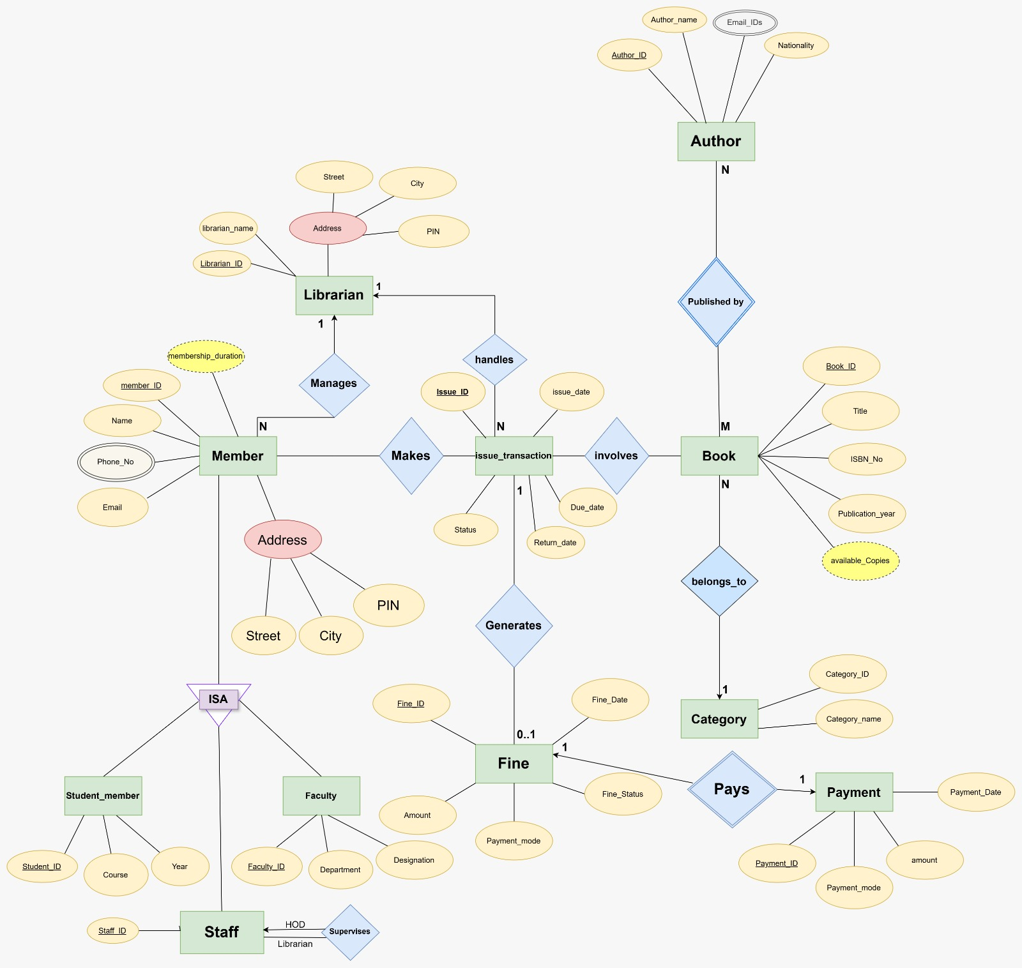
Figure 1: ER Diagram of Library Management System
The ER diagram should show BOOK, MEMBER, LIBRARIAN, AUTHOR, CATEGORY, ISSUE_TRANSACTION, and BOOK_AUTHOR, together with their attributes, primary/foreign keys, relationship names, and cardinalities. The BOOK_AUTHOR entity is used to resolve the M:N relationship between AUTHOR and BOOK.

5. RELATIONAL SCHEMA
Relation | Relational Schema
BOOK | Book_ID (PK), Title, ISBN, Publisher, Quantity, Available_Copies, Category_ID (FK)
MEMBER | Member_ID (PK), Name, Email, Phone, Address, Membership_Date
LIBRARIAN | Librarian_ID (PK), Name, Email, Phone
AUTHOR | Author_ID (PK), Author_Name
CATEGORY | Category_ID (PK), Category_Name, Description
ISSUE_TRANSACTION | Issue_ID (PK), Member_ID (FK), Book_ID (FK), Librarian_ID (FK), Issue_Date, Due_Date, Return_Date, Status
BOOK_AUTHOR | Book_ID (FK), Author_ID (FK), composite PK (Book_ID, Author_ID)

The relational schema follows the structure presented in the Library Management System project material. The BOOK relation references CATEGORY; ISSUE_TRANSACTION references MEMBER, BOOK, and LIBRARIAN; and BOOK_AUTHOR establishes the relationship between BOOK and AUTHOR using a composite primary key consisting of Book_ID and Author_ID.
.

6. TABLE DESIGN

6.1 BOOK Table
Attribute | Data Type | Constraint | Description
Book_ID | NUMBER/INT | PK, NOT NULL | Unique book identifier
Title | VARCHAR | NOT NULL | Book title
ISBN_NO | VARCHAR | UNIQUE | International book identifier
Publication_Year | NUMBER |  | Year in which the book was published.
  —
Available_Copies | NUMBER/INT | CHECK | Currently available copies
Category_ID | NUMBER/INT | FK | References CATEGORY

6.2 MEMBER Table
Attribute | Data Type | Constraint | Description
Member_ID | NUMBER/INT | PK, NOT NULL | Unique member identifier
Name | VARCHAR | NOT NULL | Member name
Email | VARCHAR | UNIQUE | Member email
Phone | VARCHAR | — | Contact number
Address | VARCHAR | — | Member address
Membership_Date | DATE | — | Date of membership

6.3 LIBRARIAN Table
Attribute | Data Type | Constraint | Description
Librarian_ID | NUMBER/INT | PK, NOT NULL | Unique librarian identifier
Name | VARCHAR | NOT NULL | Librarian name
Email | VARCHAR | UNIQUE | Librarian email
Phone | VARCHAR | — | Contact number

6.4 AUTHOR Table
Attribute | Data Type | Constraint | Description
Author_ID | NUMBER/INT | PK, NOT NULL | Unique course identifier
Author_Name | VARCHAR | NOT NULL | Author name

6.5 CATEGORY Table
Attribute | Data Type | Constraint | Description
Category_ID | NUMBER/INT | PK, NOT NULL | Unique category identifier
Category_Name | VARCHAR | NOT NULL | Category name

6.6 ISSUE_TRANSACTION Table
Attribute | Data Type | Constraint | Description
Issue_ID | NUMBER/INT | PK, NOT NULL | Unique transaction identifier
Member_ID | NUMBER/INT | FK | References MEMBER
Book_ID | NUMBER/INT | FK | References BOOK
Librarian_ID | NUMBER/INT | FK | References LIBRARIAN
Issue_Date | DATE | NOT NULL | Book issue date
Due_Date | DATE | — | Expected return date
Return_Date | DATE | — | Actual return date
Status | VARCHAR | — | Transaction status

6.7 BOOK_AUTHORN Table
Attribute | Data Type | Constraint | Description
Book_ID | NUMBER/INT | PK, FK | References BOOK
Author_ID | NUMBER/INT | PK, FK | References AUTHOR

6.8 Keys and Constraints
Constraint Type | Applied To / Purpose
Primary Key | Book_ID, Member_ID, Librarian_ID, Author_ID, Category_ID, Issue_ID, and composite Book_ID + Author_ID.
Foreign Key | Category_ID in BOOK; Member_ID, Book_ID, Librarian_ID in ISSUE_TRANSACTION; Book_ID and Author_ID in BOOK_AUTHOR
NOT NULL | Required identifiers, names, and important transaction fields.
UNIQUE | ISBN and email fields where applicable.
CHECK | Quantity and Available_Copies should remain valid non-negative values.

7. NORMALIZATION
Normalization organizes data into related relations to reduce redundancy and update anomalies. For the Library Management System, the data can be separated into BOOK, MEMBER, LIBRARIAN, AUTHOR, CATEGORY, ISSUE_TRANSACTION, and BOOK_AUTHOR relations so that each relation stores information about a particular subject.
7.5 Functional Dependencies
For example:
Member_ID → Member_Name, Email, Phone_No...
Book_ID → Book_Title, ISBN_No...
Author_ID → Author_Name...
Issue_ID → Issue_Date, Due_Date, Return_Date, Status, Member_ID, Book_ID, Librarian_ID

7.1 Unnormalized Form (UNF)
In an unnormalized design, a single library record could contain member details, book details, author details, category details, librarian details, and multiple transaction or author values together. Repeating author and transaction information can cause redundancy and make updates difficult.
Issue_ID | Member_Name | Book_ID | Book_TItle | Author_Name
101 | Rani | B01 | DBMS | Korth
101 | Rani | B02 | C++ | Balaguruswamy
102 | Swapna | B01 | DBMS | Korth

Problems in UNF
- Book details are repeated.
- Member details are repeated.
- Author details are repeated.
- Librarian details are repeated.
- Data redundancy occurs.
- Repeating book information exists for one issue.

7.2 First Normal Form (1NF)
- Each attribute contains a single atomic value.
- Repeating groups are removed.

Issue_ID | Member_Name | Book_ID | Book_Title | Author_Name
101 | Rani | B01 | DBMS | Korth
101 | Rani | B02 | C++ | Balaguruswamy
102 | Swapna | B01 | DBMS | Korth

Composite Primary Key: (Issue_ID, Book_ID)

7.3 Second Normal Form (2NF)
- Non-key attributes must depend on the whole key.
There are partial dependencies:
- Issue_ID → Member_Name
- Book_ID → Book_Title, Author_Name
So we decompose:
ISSUE

Issue_ID | Member_Name
101 | Rani
102 | Swapna

BOOK

Book_ID | Book_Title | Author_Name
B01 | DBMS | Korth
B02 | C++ | Balaguruswamy

ISSUE_BOOK

Issue_ID | Book_ID
101 | B01
102 | B02
102 | B01

This removes the partial dependency.

7.4 Third Normal Form (3NF)
- Transitive dependencies are removed.
To demonstrate 3NF, take the BOOK table and add Author_ID:
Book_ID | Book_Title | Author_ID | Author_Name
B01 | DBMS | A01 | Korth
B02 | C++ | A02 | Balaguruswamy

Here:
Book_ID → Author_ID
Author_ID → Author_Name
So there is a transitive dependency.
Decompose into:
BOOK
Book_ID | Book_Title | Author_ID
B01 | DBMS | A01
B02 | C++ | A02

AUTHOR
Author_ID | Author_Name
A01 | Korth
A02 | Balaguruswamy

Now the transitive dependency is removed.

8. SQL IMPLEMENTATION

8.1 DDL – Data Definition Language
The following DDL is a documentation-ready implementation aligned with the supplied relational schema. Data types may be adjusted to the specific DBMS used by the student team.
CREATE TABLE Librarian (
Librarian_ID NUMBER PRIMARY KEY,
Librarian_name VARCHAR2(50),
Street VARCHAR2(50),
City VARCHAR2(30),
PIN VARCHAR2(10)
);
CREATE TABLE Member (
Member_ID NUMBER PRIMARY KEY,
Name VARCHAR2(50),
Email VARCHAR2(100),
Phone_No varchar2(15),
Street VARCHAR2(50),
City VARCHAR2(30),
PIN VARCHAR2(10),
Membership_Date DATE,
Membership_Type VARCHAR2(30)
);
CREATE TABLE Book (
Book_ID NUMBER PRIMARY KEY,
Title VARCHAR2(100),
ISBN_No VARCHAR2(20),
Publication_Year NUMBER(4),
Available_Copies NUMBER
);
CREATE TABLE Category (
Category_ID NUMBER PRIMARY KEY,
Category_Name VARCHAR2(50)
);
CREATE TABLE Author (
Author_ID NUMBER PRIMARY KEY,
Author_Name VARCHAR2(100),
Email_ID VARCHAR2(100),
Nationality VARCHAR2(50)
);
CREATE TABLE Fine (
Fine_ID NUMBER PRIMARY KEY,
Fine_Date DATE,
Amount NUMBER(10,2),
Fine_Status VARCHAR2(20),
Payment_Mode VARCHAR2(30)
);
CREATE TABLE Payment (
Payment_ID NUMBER PRIMARY KEY,
Payment_Date DATE,
Amount NUMBER(10,2),
Payment_Mode VARCHAR2(30)
);
CREATE TABLE Stuudent (
Student_ID NUMBER PRIMARY KEY,
Course VARCHAR2(50),
Year NUMBER,
FOREIGN KEY (Student_ID) REFERENCES Member(Member_ID)
);
CREATE TABLE Staff (
Staff_ID NUMBER PRIMARY KEY,
FOREIGN KEY (Staff_ID) REFERENCES Member(Member_ID)
);
CREATE TABLE Issue_Transaction (
Issue_ID NUMBER PRIMARY KEY,
Issue_Date DATE,
Due_Date DATE,
Return_Date DATE,
Status VARCHAR2(20),
Member_ID NUMBER,
Book_ID NUMBER,
Librarian_ID NUMBER,
FOREIGN KEY (Member_ID) REFERENCES Member(Member_ID),
FOREIGN KEY (Book_ID) REFERENCES Book(Book_ID),
FOREIGN KEY (Librarian_ID) REFERENCES Librarian(Librarian_ID)
);
ALTER TABLE Issue_Transaction ADD (
Member_ID NUMBER,
Book_ID NUMBER,
Librarian_ID NUMBER
);

ALTER TABLE Issue_Transaction
ADD CONSTRAINT fk_issue_member
FOREIGN KEY (Member_ID) REFERENCES Member(Member_ID);

ALTER TABLE Issue_Transaction
ADD CONSTRAINT fk_issue_book
FOREIGN KEY (Book_ID) REFERENCES Book(Book_ID);

ALTER TABLE Issue_Transaction
ADD CONSTRAINT fk_issue_librarian
FOREIGN KEY (Librarian_ID) REFERENCES Librarian(Librarian_ID);

ALTER TABLE Book ADD (
Category_ID NUMBER
);

ALTER TABLE Book
ADD CONSTRAINT fk_book_category
FOREIGN KEY (Category_ID)
REFERENCES Category(Category_ID);

CREATE TABLE Published_By (
Author_ID NUMBER,
Book_ID NUMBER,
PRIMARY KEY (Author_ID, Book_ID),
FOREIGN KEY (Author_ID) REFERENCES Author(Author_ID),
FOREIGN KEY (Book_ID) REFERENCES Book(Book_ID)
);

ALTER TABLE Fine ADD (
Issue_ID NUMBER
);

ALTER TABLE Fine
ADD CONSTRAINT fk_fine_issue
FOREIGN KEY (Issue_ID)
REFERENCES Issue_Transaction(Issue_ID);

ALTER TABLE Payment ADD (
Fine_ID NUMBER
);
ALTER TABLE Payment
ADD CONSTRAINT fk_payment_fine
FOREIGN KEY (Fine_ID)
REFERENCES Fine(Fine_ID);

ALTER TABLE Payment
ADD CONSTRAINT uq_payment_fine UNIQUE (Fine_ID
);
ALTER TABLE Member ADD (
Librarian_ID NUMBER
);
ALTER TABLE Member
ADD CONSTRAINT fk_member_librarian
FOREIGN KEY (Librarian_ID)
REFERENCES Librarian(Librarian_ID);

8.2 DML – Data Manipulation Language
INSERT INTO Librarian VALUES (1, 'Anitha', 'Main Street', 'Kakinada', '533001');
INSERT INTO Librarian VALUES (2, 'Ravi', 'MG Road', 'Rajahmundry', '533101');
INSERT INTO Member
(Member_ID, Name, Email, Phone_No, Street, City, PIN, Membership_Date, Membership_Type, Librarian_ID)
VALUES(1, 'Pujitha', 'pujitha@gmail.com', '9876500001', 'MG Road', 'Kakinada', '533001', DATE '2026-01-10', 'Student', 1);
INSERT INTO Member(Member_ID, Name, Email, Phone_No, Street, City, PIN, Membership_Date, Membership_Type, Librarian_ID) VALUES (2, 'Anjali', 'anjali@gmail.com', '9876500002', 'Main Road', 'Rajahmundry', '533101', DATE '2026-01-15', 'Student', 1);
INSERT INTO Category VALUES (1, 'Computer Science');
INSERT INTO Category VALUES (2, 'Database Systems');
INSERT INTO Book VALUES (1, 'Database Management Systems', '9781000000001', 2024, 5, 2);
INSERT INTO Book VALUES (2, 'Computer Fundamentals', '9781000000002', 2023, 8, 1);
INSERT INTO Author VALUES (1, 'R.K. Narayan', 'rknarayan@gmail.com', 'Indian');
INSERT INTO Author VALUES (2, 'Chetan Bhagat', 'chetanbhagat@gmail.com', 'Indian');
INSERT INTO Issue_Transaction (Issue_ID, Issue_Date, Due_Date, Return_Date, Status, Member_ID, Book_ID, Librarian_ID)
VALUES (1, DATE '2026-06-01', DATE '2026-06-15', DATE '2026-06-14', 'Returned', 1, 1, 1);
INSERT INTO Issue_Transaction VALUES (2, DATE '2026-06-02', DATE '2026-06-16', NULL, 'Issued', 2, 3, 1);
INSERT INTO Fine (Fine_ID, Fine_Date, Amount, Fine_Status, Payment_Mode, Issue_ID) VALUES (1, DATE '2026-06-16', 20, 'Paid', 'UPI', 1);
INSERT INTO Fine VALUES (2, DATE '2026-06-18', 30, 'Unpaid', 'Cash', 3);
INSERT INTO Fine VALUES (3, DATE '2026-06-20', 25, 'Paid', 'UPI', 5);
INSERT INTO Payment (Payment_ID, Payment_Date, Amount, Payment_Mode, Fine_ID) VALUES (1, DATE '2026-06-17', 20, 'UPI', 1);
INSERT INTO Payment VALUES (2, DATE '2026-06-19', 30, 'Cash', 2);
INSERT INTO Payment VALUES (3, DATE '2026-06-21', 25, 'UPI', 3);
INSERT INTO Stuudent VALUES (1, 'CSE', 2);
INSERT INTO Stuudent VALUES (2, 'ECE', 3);
INSERT INTO Faculty VALUES (1, 'Computer Science', 'Professor');
INSERT INTO Faculty VALUES (2, 'Electronics', 'Assistant Professor');
INSERT INTO Staff VALUES (1);
INSERT INTO Staff VALUES (2);
INSERT INTO Published_By VALUES (1, 1);
INSERT INTO Published_By VALUES (2, 2);

8.3 DQL – Data Query Language
SELECT * FROM Librarian;
SELECT * FROM Member;
SELECT * FROM Category;
SELECT * FROM Book;
SELECT * FROM Author;
SELECT * FROM Issue_Transaction;
SELECT * FROM Fine;
SELECT * FROM Payment;
SELECT * FROM Stuudent;
SELECT * FROM Faculty;
SELECT * FROM Staff;
SELECT * FROM Published_By;

SELECT Name, Email, Membership_Type
FROM Member;

SELECT Book_ID, Title, Publication_Year
FROM Book
WHERE Publication_Year > 2023;

SELECT COUNT(*) AS Total_Books
FROM Book;

SELECT Category_ID, COUNT(*) AS Total_Books
FROM Book
GROUP BY Category_ID;

SELECT M.Name, I.Issue_ID, I.Issue_Date
FROM Member M
INNER JOIN Issue_Transaction I
ON M.Member_ID = I.Member_ID;

SELECT Name
FROM Member
WHERE Member_ID IN (
SELECT Member_ID
FROM Issue_Transaction
);

SELECT Librarian_name
FROM Librarian
WHERE Librarian_ID NOT IN (
SELECT Librarian_ID
FROM Issue_Transaction
);

SELECT Librarian_name
FROM Librarian
WHERE Librarian_ID NOT IN (
SELECT Librarian_ID
FROM Issue_Transaction
);

SELECT Name
FROM Member
WHERE Member_ID IN (
SELECT Member_ID
FROM Issue_Transaction
WHERE Book_ID IN (
SELECT Book_ID
FROM Book
WHERE Category_ID IN (
SELECT Category_ID
FROM Category
WHERE Category_Name = 'Database Systems'
)
)
);

SELECT Book_ID, Title, Available_Copies
FROM Book
WHERE Available_Copies > ANY (
SELECT Available_Copies
FROM Book
WHERE Category_ID = 1
);

SELECT Librarian_name
FROM Librarian L
WHERE EXISTS (
SELECT 1
FROM Issue_Transaction I
WHERE I.Librarian_ID = L.Librarian_ID
);

SELECT Librarian_name
FROM Librarian L
WHERE NOT EXISTS (
SELECT 1
FROM Issue_Transaction I
WHERE I.Librarian_ID = L.Librarian_ID
);

SELECT Issue_ID, Member_ID, Book_ID, Issue_Date
FROM Issue_Transaction
WHERE Status = 'Issued';

UPDATE Member SET Membership_Type = 'Faculty' WHERE Member_ID = 1;
UPDATE Member SET Membership_Type = 'Student' WHERE Member_ID = 1;

SELECT Fine_ID, Issue_ID, Amount, Fine_Status
FROM Fine
WHERE Fine_Status = 'Unpaid';

SELECT AVG(Amount) AS Average_Fine
FROM Fine;

SELECT SUM(Amount) AS Total_Fine_Amount
FROM Fine;

SELECT Librarian_ID
FROM Librarian
INTERSECT
SELECT Librarian_I FROM Issue_Transaction;
9. SQL QUERIES & SCREENSHOTS
The following query set is prepared to satisfy the documentation requirement for a 30–40 query SQL section. The examples cover selection, filtering, joins, aggregation, subqueries, updates, deletion, and reporting. Exact outputs depend on the records inserted in the final project database.

Q1. Display all books
SELECT * FROM Book;
Output:
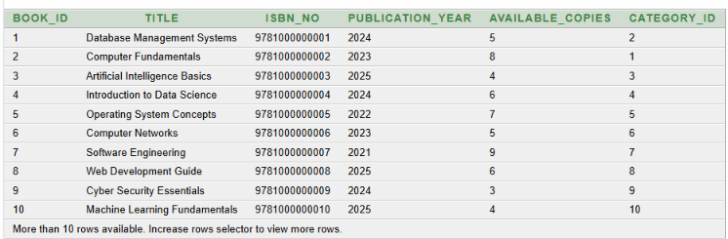
Figure 2. Book Management Screen – Placeholder
Q2. Display all members
SELECT * FROM Member

Output: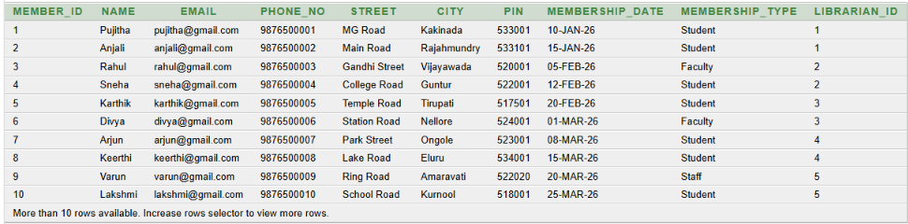
Figure 3. Member Management Screen – Placeholder

Q3. Display all records of Category
SELECT * FROM Category;
Output:
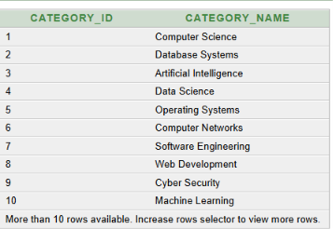
Q4. Display all librarians
SELECT * FROM Librarian;
Output:
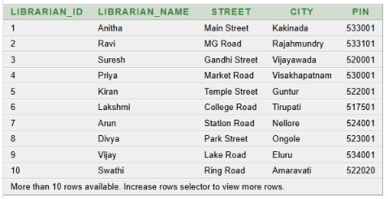
Figure 4. Library Report Generation Screen – Placeholder

Q5. Display all authors
SELECT * FROM author;
Output:
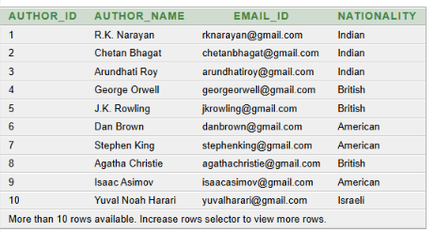
Q6. Select all records from issue_transaction table
SELECT * FROM issue_transaction;
Output:
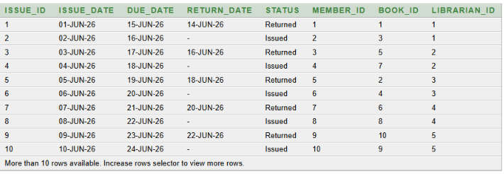
Figure 5. Book Issue / Return Screen – Placeholder

Q7. Display all records of FIne
SELECT * FROM Fine;
Output:
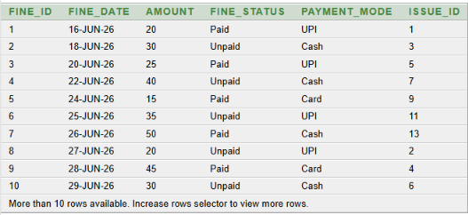
Q8. Display all records of Payment
SELECT * FROM Payment;
Output:
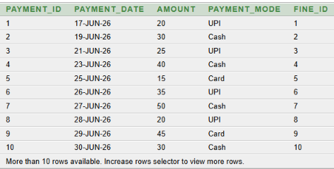
Figure 6. Fine and Payment Management Screen – Placeholder
Q9. Display all records of Faculty
SELECT * FROM Faculty;
Output:
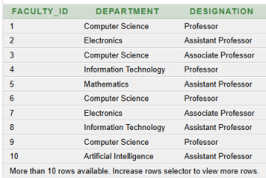
Q10. Display all records of Staff
SELECT * FROM Staff;
Output:
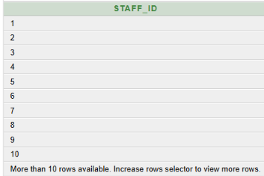
Q11. Display all records of Published_By
SELECT * FROM Published_By;
Output:
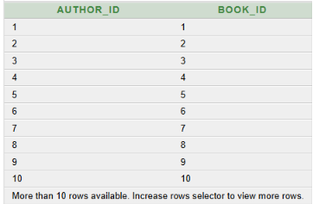
Q12. Display the name, email and membership type of all members.
SELECT Name, Email, Membership_Type FROM Member;
Output:
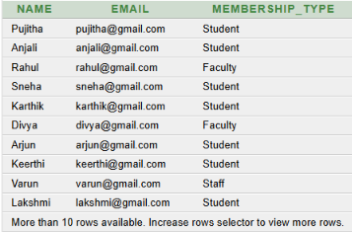
Q13. Display the BOOK ID,title and publication year of books published after 2023.
SELECT Book_ID, Title, Publication_Year FROM Book WHERE Publication_Year > 2023;
Output:
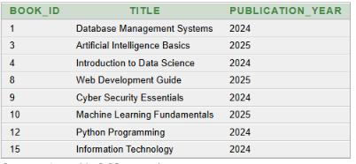
Q14. Find the total number of books e available in the library.
SELECT count(*) AS Total_Books FROM Book;
Output:
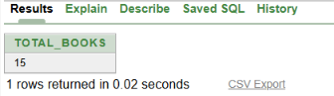
Q15. Find the total number of books in each category
SELECT Category_ID, COUNT(*) AS Total_Books FROM Book GROUP BY Category_ID;
Output:
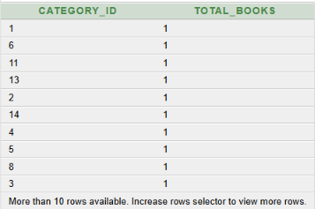
Q16. Display the member name, issue ID and issue date for all book issue transactions.
SELECT M.Name, I.Issue_ID, I.Issue_Date FROM Member M INNER JOIN Issue_Transaction I ON M.Member_ID = I.Member_ID;
Output:
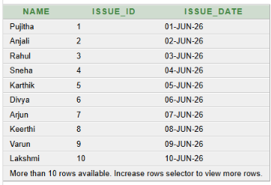
Q17. Display the names of members who have issued at least one book.
SELECT Name FROM Member WHERE Member_ID IN ( SELECT Member_ID FROM Issue_Transaction );

Output:
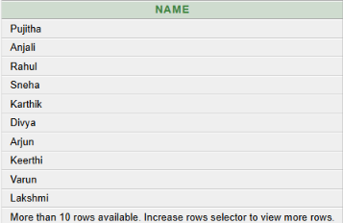
Q18. Display the names of librarians who have not handled any book issue transaction.
SELECT Librarian_name FROM Librarian WHERE Librarian_ID NOT IN ( SELECT Librarian_ID FROM Issue_Transaction );
Output:
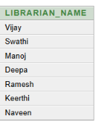
Q19. Display the names of members who have issued books belonging to the “Database Systems” category
SELECT Name FROM Member WHERE Member_ID IN (SELECT Member_ID FROM Issue_Transaction WHERE Book_ID IN (SELECT Book_ID FROM Book WHERE Category_ID IN (SELECT Category_ID FROM Category WHERE Category_Name = 'Database Systems')));
Output:
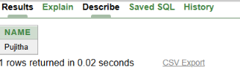
Q20. Display books whose available copies are greater than any book in Category ID 1
SELECT Book_ID, Title, Available_Copies FROM Book WHERE Available_Copies > ANY (SELECT Available_Copies FROM Book WHERE Category_ID = 1);

Output:
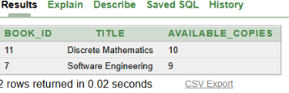
Q21. Display the names of librarians who have handled at least one book issue transaction.
SELECT Librarian_name FROM Librarian L WHERE EXISTS (SELECT 1 FROM Issue_Transaction I WHERE I.Librarian_ID = L.Librarian_ID);
Output:
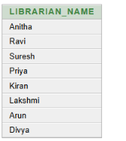
Q22. Display the names of librarians who have not handled any book issue transaction.
SELECT Librarian_name FROM Librarian L WHERE NOT EXISTS (SELECT 1 FROM Issue_Transaction I WHERE I.Librarian_ID = L.Librarian_ID);
Output:
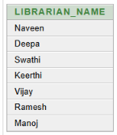
Q23. Display all book issue transactions whose status is 'Issued'.
SELECT ssue_ID, Member_ID, Book_ID, Issue_Date FROM Issue_Transaction WHERE Status = 'Issued’;
Output:
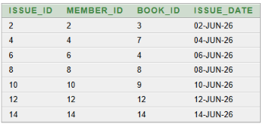
Q24. Update the membership type of Member ID 1 to 'Faculty'.
UPDATE Member SET Membership_Type=’Faculty’ WHERE Member_ID=1;
SELECT * FROM Member;
Output:
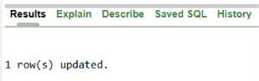
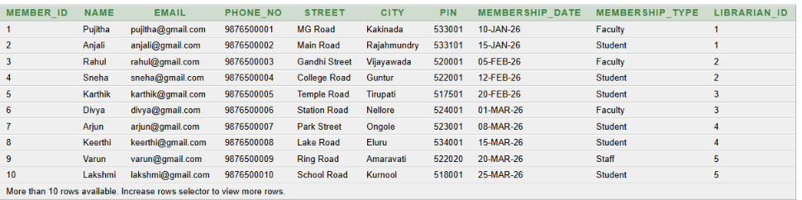
Q25. Update the membership type of Member ID 1 to 'Student'.
UPDATE Member SET Membership_Type=’Student’ WHERE Member_ID=1;
SELECT * FROM Member;
Output:
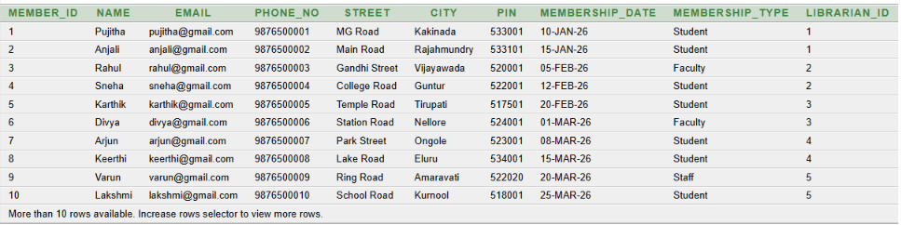
Q26. Display all unpaid fines along with Fine ID, Issue ID, amount, and fine status.
SELECT Fine_ID, Issue_ID, Amount, Fine_Status FROM Fine WHERE Fine_Status='Unpaid';

Output:
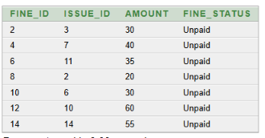
Q27. Find the average fine amount.
SELECT AVG(Amount) AS Average_Fine FROM Fine;
Output:
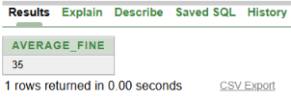
Q28. Find the total amount of all fines.
SELECT SUM(Amount) AS Total_Fine_Amount FROM Fine;
Output:
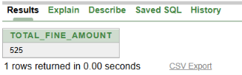
Q29. Find the librarian IDs that exist both in the Librarian table and the Issue_Transaction table.
SELECT Librarian_ID FROM Librarian INTERSECT SELECT Librarian_ID FROM Issue_Transaction;
Output:
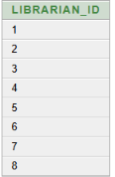
Q30. Display all books in ascending order of their titles?
SELECT Book_ID, Title, Publication_year FROM Book ORDER BY Title ASC;
Output:
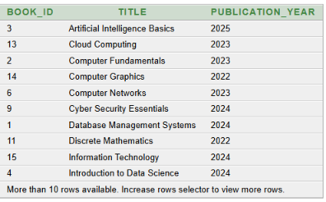
11. CONCLUSION
The Library Management System provides a structured relational database solution for managing core library information. The design organizes librarians, members, books, categories, authors, issue transactions, fines, payments, and publishing relationships into related relations and applies primary keys, foreign keys, and other constraints to support data integrity. The normalization process helps reduce data redundancy and update anomalies. The SQL implementation and query set demonstrate how the database can support insertion, modification, retrieval, aggregation, and library-related reporting. The project therefore provides a suitable DBMS cornerstone implementation that can be extended into a complete library management system.

12. FUTURE ENHANCEMENTS
- Role-based access for librarians, members, and other authorized users.
- Online book search and reservation facility.
- Automated fine calculation and payment management.
- Book availability and issue/return tracking in real time.
- Automated library reports and analytics dashboards.
- Backup, recovery, audit logging, and stronger database security.

REFERENCES
- Supplied PowerPoint: “Library Management System Review 2”, 2026.
- Supplied Oracle SQL source: “Library Management System SQL Source”, containing DDL, ALTER TABLE, INSERT statements, constraints, and SQL queries.
- Korth, H. F., Silberschatz, A., and Sudarshan, S., Database System Concepts, McGraw Hill.
- Elmasri, R. and Navathe, S. B., Fundamentals of Database Systems, Pearson.
- Oracle Database Documentation, Oracle SQL Language Reference – https://docs.oracle.com/en/database/oracle/oracle-database/26/sqlrf/
- W3Schools, SQL Tutorial – https://www.w3schools.com/sql/

